Name : Welly

E-mail : [wellytan09@gmail.com](mailto:wellytan09@gmail.com)

**Preview**

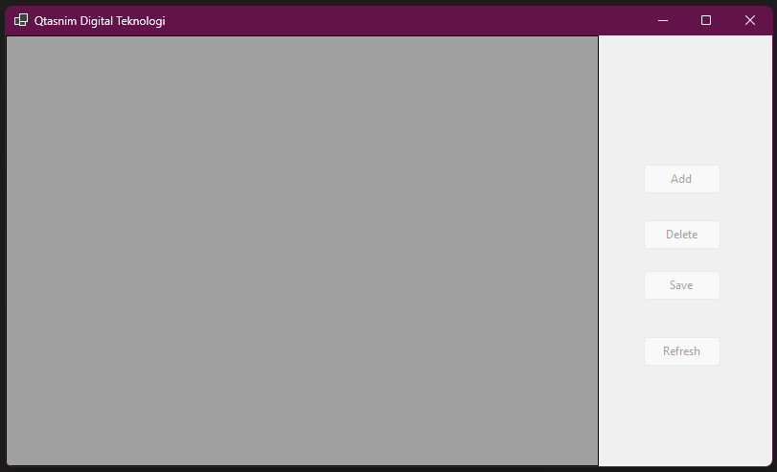

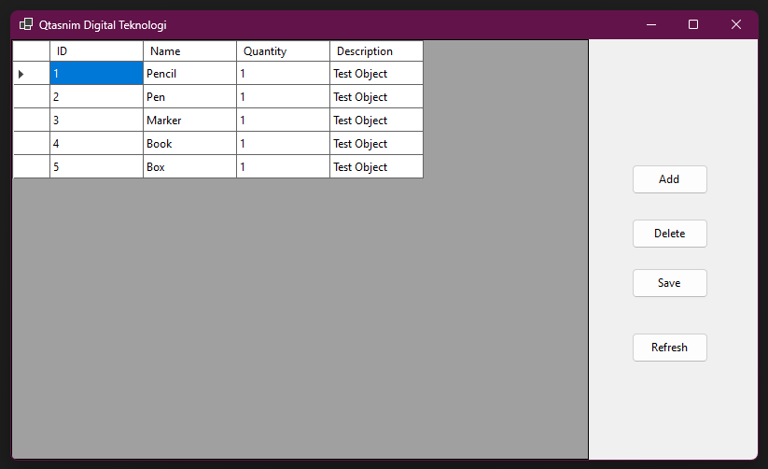

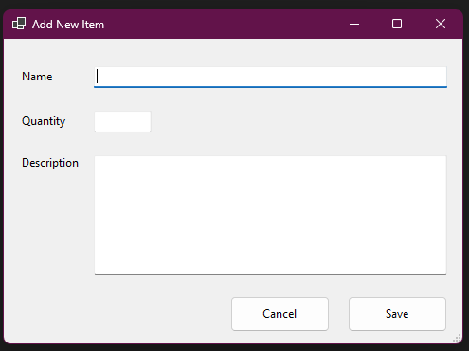

This is app in **NOT FINISHED**

(Duration: 24 Hour)

Note:

1. This app can be found in ” ..\Qtasnim Digital Teknologi\bin\Debug\net8.0-windows”, app name is “Qtasnim Digital Teknologi.exe”. Recommend using Visual Studio 2022
2. You need to change server name and database name on “App.config”. File Location is ” ..\Qtasnim Digital Teknologi” and you can open with notepad or else.
3. This Software use C# Language and Entity Framework.
4. My design is using Code First Approach, so if you use new server or new database, you can use my code for initial migration. If you use existing server or database, you can open it directly
5. This app is design for **SQL SERVER**, If you want to use another server you need to add some code on “ApplicationDBContext.cs” on Data folder
6. This App has been tested for connecting to SQL Server, Fetch data from server, delete data, and Add data to server.
7. Task not finished:
   1. Edit Data
   2. Integrated to HTTP Client
   3. Exception Handling

Source Code:

<https://github.com/DoomedMean/Company-Test/tree/main/Qtasnim%20Digital%20Teknologi>